Table 13-1
Number of Workers | Total Output | Marginal Product
0 | 0 | --
1 |  | 30
2 |  | 45
3 |  | 60
4 |  | 50
5 |  | 40

1. Refer to Table 13-1. What is total output when 1 worker is hired?

2. Refer to Table 13-1. What is total output when 4 workers are hired?

Table 13-2
Number of Workers | Total Output | Marginal Product
0 | 0 | --
1 | 300
2 | 500
3 | 600
4 | 650

3. Refer to Table 13-2. What is the marginal product of the first worker?

4. Refer to Table 13-2. What is the marginal product of the third worker?

5. Refer to Table 13-2. At which number of workers does diminishing marginal product begin?

Table 13-3
Number of  Workers | Output | Fixed  Cost | Variable  Cost | Total  Cost
0 | 0 | $50 | $0 | $50
1 | 90 | $50 | $20 | $70
2 | 170 | $50 | $40 | $90
3 | 230 | $50 | $60 | $110
4 | 240 | $50 | $80 | $130

6. Refer to Table 13-3. The marginal product of the fourth worker is

7. Refer to Table 13-3. If the firm can sell its output for $1 per unit, what is the profit-maximizing level of output?

Table 13-7
The Flying Elvis Copter Rides
Quantity | Total  Cost | Fixed  Cost | Variable  Cost | Marginal  Cost | Average  Fixed  Cost | Average  Variable  Cost | Average  Total  Cost
0 | $50 | $50 | $0 | -- | -- | -- | --
1 | $150 | A | B | C | D | E | F
2 | G | H | I | $120 | J | K | L
3 | M | N | O | P | Q | $120 | R

8. Refer to Table 13-7. What is the value of A?

9. Refer to Table 13-7. What is the value of B?

10. Refer to Table 13-7. What is the value of G?

11. Refer to Table 13-7. What is the value of J?

12. Refer to Table 13-7. What is the value of L?

13. Refer to Table 13-7. What is the value of M?

14. Refer to Table 13-7. What is the value of O?

15. Refer to Table 13-7. What is the value of P?

Table 13-8
Quantity  of Output | Fixed  Cost | Variable  Cost
0 | $20 | $0
1 | $20 | $10
2 | $20 | $40
3 | $20 | $80
4 | $20 | $130
5 | $20 | $200
6 | $20 | $300

16. Refer to Table 13-8. What is the average fixed cost of producing 5 units of output?

17. Refer to Table 13-8. What is the marginal cost of producing the fifth unit of output?

Table 13-17
Consider the following table of long-run total cost for four different firms:
Quantity | 1 | 2 | 3 | 4 | 5 | 6 | 7
Firm 1 | $180 | $350 | $510 | $660 | $800 | $930 | $1,050
Firm 2 | $120 | $250 | $390 | $540 | $700 | $870 | $1,050
Firm 3 | $150 | $300 | $450 | $600 | $750 | $900 | $1,050
Firm 4 | $210 | $340 | $490 | $660 | $850 | $1,060 | $1,290

18. Refer to Table 13-17. Which firm has constant returns to scale over the entire range of output?

19. Refer to Table 13-17. Which firm has economies of scale over the entire range of output?

20. Refer to Table 13-17. Which firm has diseconomies of scale over the entire range of output?

Table 14-7
Suppose that a firm in a competitive market faces the following revenues and costs:
 | Marginal | Marginal
Quantity | Cost | Revenue
12 | $5 | $7.50
13 | $6 | $7.50
14 | $7 | $7.50
15 | $8 | $7.50
16 | $9 | $7.50
17 | $10 | $7.50

21. Refer to Table 14-7. If the firm is currently producing 14 units, what would you advise the owners?

Figure 14-2
Suppose a firm operating in a competitive market has the following cost curves:
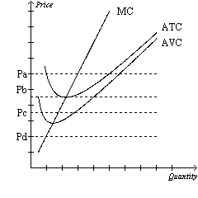
22. Refer to Figure 14-2. If the market price is Pa, in the short run the firm will earn

23. Refer to Figure 14-2. If the market price is Pb, in the short run the firm will earn

24. Refer to Figure 14-2. If the market price is Pc, in the short run the firm will earn

25. Refer to Figure 14-2. If the market price is Pd, in the short run the firm will earn

Figure 14-5
Suppose a firm operating in a competitive market has the following cost curves:
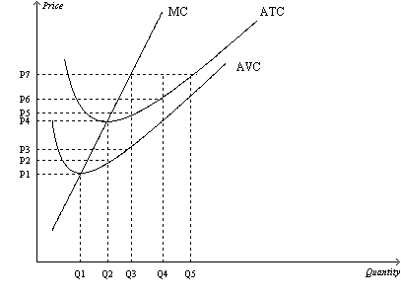

26. Refer to Figure 14-5. When market price is P7, a profit-maximizing firm's short-run profits can be represented by the area

27. Refer to Figure 14-5. In the short run, if the market price is higher than P1 but less than P4, individual firms in a competitive industry will earn

28. Refer to Figure 14-5. Firms would be encouraged to enter this market for all prices that exceed

29. Refer to Figure 14-5. In the short run,if the market price is higher than P4 but less than P6, individual firms in a competitive industry will earn

Figure 14-13
Suppose a firm in a competitive industry has the following cost curves:
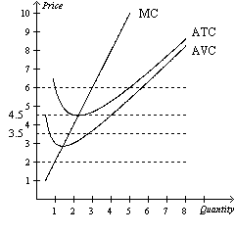

30. Refer to Figure 14-13. If the price is $6 in the short run, what will happen in the long run?

31. Refer to Figure 14-13. If the price is $4.50 in the short run, what will happen in the long run?

Figure 15-5
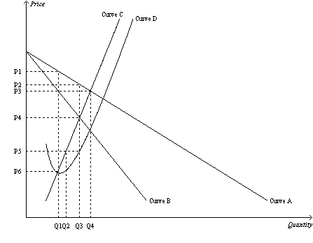

32. Refer to Figure 15-5. A profit-maximizing monopoly will produce an output level of

33. Refer to Figure 15-5. A profit-maximizing monopoly will charge a price of

34. Refer to Figure 15-5. A profit-maximizing monopoly's total revenue is equal to

35. Refer to Figure 15-5. A profit-maximizing monopoly's total cost is equal to

36. Refer to Figure 15-5. A profit-maximizing monopoly's profit is equal to

Table 15-5
A monopolist faces the following demand curve:
Price | Quantity
$51 | 1
$47 | 2
$42 | 3
$36 | 4
$29 | 5
$21 | 6
$12 | 7

37. Refer to Table 15-5. The monopolist has total fixed costs of $60 and has a constant marginal cost of $15. What is the profit-maximizing level of production?

38. Refer to Table 15-5. The monopolist has total fixed costs of $60 and has a constant marginal cost of $15. What is the profit-maximizing price?

